Dayananda Sagar College of Engineering
Department of Electronics and Communication Engineering
Shavige Malleshwara Hills, Kumaraswamy Layout, Bengaluru – 560 078.
(An Autonomous Institute affiliated to VTU, Approved by AICTE & ISO 9001:2008 Certified)
Accredited by National Assessment and Accreditation Council (NAAC) with ‘A’ grade

AAT 2

Program: B.E. | Branch: ECE
Course: B.E | Semester : VI
Course Code: EC064 | Date:

A Report on

Generation and simulation of Convolutional Codes using MATLAB

Submitted by

Sl. No. | USN | NAME
1. | 1DS15EC067 | MD SARFRAZ
2 | 1DS15EC091 | RAJAT SUGANDHI
3 | 1DS15EC077 | NC CHARAN
4 | 1DS15EC075 | NISANTH SAHAY

Faculty In-charge

Prof. DEEPA N P

INTRODUCTION
Shannon's source coding theorem (or noiseless coding theorem) establishes the limits to possible data compression, and the operational meaning of the Shannon entropy.
The source coding theorem shows that (in the limit, as the length of a stream of independent and identically-distributed random variable data tends to infinity) it is impossible to compress the data such that the code rate (average number of bits per symbol) is less than the Shannon entropy of the source, without it being virtually certain that information will be lost. However, it is possible to get the code rate arbitrarily close to the Shannon entropy, with negligible probability of loss.
The source coding theorem for symbol codes places an upper and a lower bound on the minimal possible expected length of codewords as a function of the entropy of the input word (which is viewed as a random variable) and of the size of the target alphabet.
THEORY
In the field of data compression, Shannon coding, named after its creator, Claude Shannon, is a lossless data compression technique for constructing a prefix code based on a set of symbols and their probabilities (estimated or measured). It is suboptimal in the sense that it does not achieve the lowest possible expected code word length like Huffman coding does, and never better but sometimes equal to the Shannon-Fano coding.
The method was the first of its type, the technique was used to prove Shannon's noiseless coding theorem in his 1948 article "A Mathematical Theory of Communication",^{[1]} and is therefore a centerpiece of the information age.
This coding method gave rise to the field of information theory and without its contribution, the world would not have any of the many successors; for example Shannon-Fano coding, Huffman coding, or arithmetic coding. Much of our day-to-day lives are significantly influenced by digital data and this would not be possible without Shannon coding and its ongoing evolution of its predecessor coding methods.
The shannon’s Binary encoding procedure is given as follows
- List the source symbols in the order of non-increasing probabilities
- Compute the sequence Alpha_{q+1}=P_{q}+P_{q-1}+…+P₂+P₁=P_{q}+Alpha_{q}
- Determine the smallest integer valjue of L_{i} using the inequality
2^{Li}>=1/P_{i} for all i=1,2…q
- Expand the decimal number Alpha_{i} in binary frp, ipto L_{i} places neglecting expansion beyond L_{i} places
- Remove the binary point to get the desired code.
- Find entropy H(s) and Average length L
- Compute efficiency as H(s)/L and redundancy as 1-H(s)/L
Algorithm

Shannon’s Binary encoding procedure using MATLAB
- Input the message codes
- Input their probabilities in the decreasing order
- Find the value of alpha using Alpha_{q+1}=P_{q}+Alpha_{q}
- Find each code length using 2^{li}>1/P_{i}
- Compute each codeword by converting alpha value from base 10 to base 2
- Compute average code length and entropy
- Compute efficiency as H(s)/L and redundancy as 1-H(s)/L

CODE

clc;
clear all;
close all;

m=input('Enter the no. of message ensembles : ');
z=[];
h=0;l=0;
display('Enter the probabilities in descending order');
for i=1:m
fprintf('Ensemble %d\n',i);
p(i)=input('');
end
%Finding each alpha values
a(1)=0;
for j=2:m;
a(j)=a(j-1)+p(j-1);
end
fprintf('\n Alpha Matrix');
display(a);
%Finding each code length
for i=1:m
n(i)= ceil(-1*(log2(p(i))));
end
fprintf('\n Code length matrix');
display(n);
%Computing each code
for i=1:m
int=a(i);
for j=1:n(i)
frac=int*2;
c=floor(frac);
frac=frac-c;
z=[z c];
int=frac;
end
fprintf('Codeword %d',i);
display(z);
z=[];
end
%Computing Avg. Code Length & Entropy
fprintf('Avg. Code Length');
for i=1:m
x=p(i)*n(i);
l=l+x;
x=p(i)*log2(1/p(i));
h=h+x;
end
display(l);
fprintf('Entropy');
display(h);
%Computing Efficiency
fprintf('Efficiency');
display(100*h/l);
fprintf('Redundancy');
display(100-(100*h/l));

Output

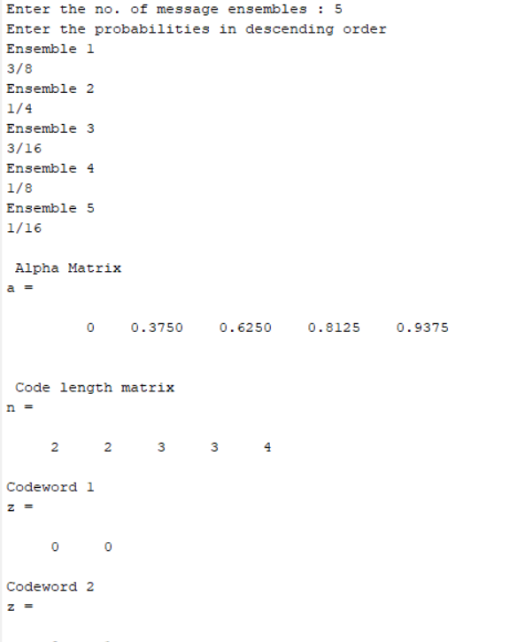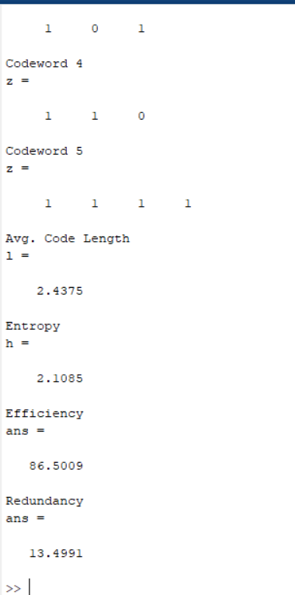

Applications
- Convolutional codes are used for reliable data transfer in numerous applications, such as digital video, radio, mobile communications and satellite communications.
- Trellis code is used in Digital Microwave Systems
- Source encoding is using in Digital communication for secure and noiseless transmission
- Shannon’s source encoding can be used in Cryptography
References
- "Information Theory and Coding", by Prof. K. Giridhar, pooja publications.
- David J. C. MacKay. Information Theory, Inference, and Learning Algorithms Cambridge: Cambridge University Press, 2003. ISBN 0-521-64298-1
- Cover, Thomas M. (2006). "Chapter 5: Data Compression". Elements of Information Theory. John Wiley & Sons. ISBN 0-471-24195-4.
- www.complextoreal.com/wp-content/uploads/2013/01/tcm.pdf
- www.eecs.umich.edu/courses/eecs555/lect08.pdf

